PROJECT REPORT :KEERTHI SWEETS
1, INTRODUCTION :
☆ Overview:
Zoho Books is an online accounting and bookkeeping software designed for small and Zoho designed for small and medium-sized businesses. It suite of cloud-based Books is an online accounting and book keeping software.
Integration: Zoho Books can be integrated with other Zoho applications as well as third-party software to streamline various business processes.
Security: Zoho Books employs security measures to protect your financial data, such as data encryption and secure data centers.
☆purpose:
When you mention integrating "Keerthi Sweets" with "Zoho Books," it likely means using Zoho Books for financial and accounting purposes within the Keerthi Sweets business. This can involve tasks such as managing sales and expenses, tracking inventory, generating invoices, and keeping financial records.
▪PRODUCTION:
Keerthi" appears to be a name.
"Sweet" could refer to a type of food or dessert."Zoho" is a software company known for its suite of cloud-based applications."Book" typically refers to a written or printed work."Production" can mean the process of creating something, such as a book.

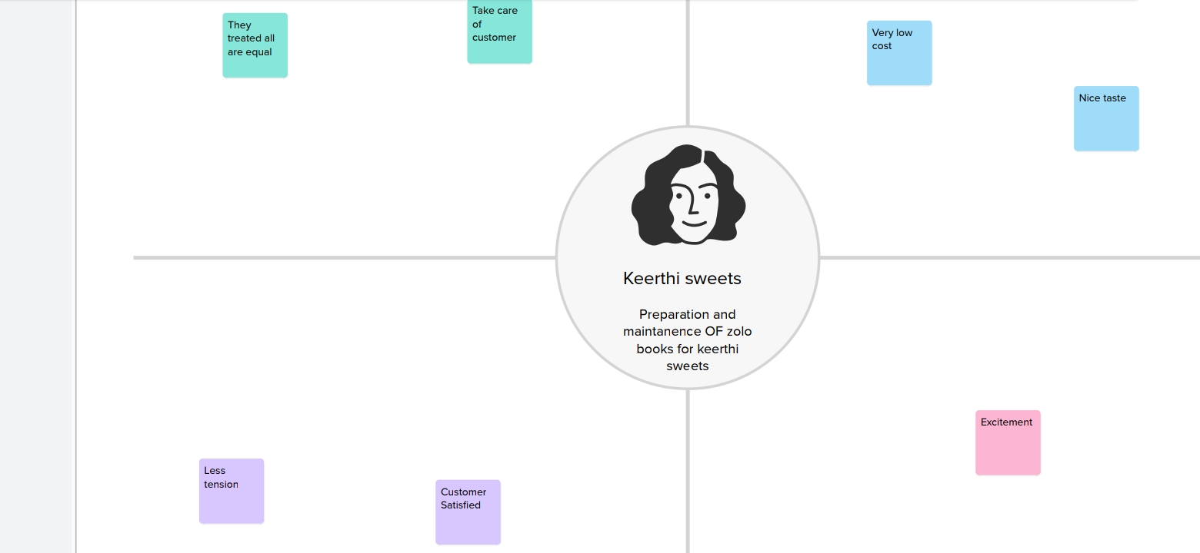
2; Problem Definition & Design Thinking:
☆Empathy Map:
☆Ideation & Brainstorming Map:

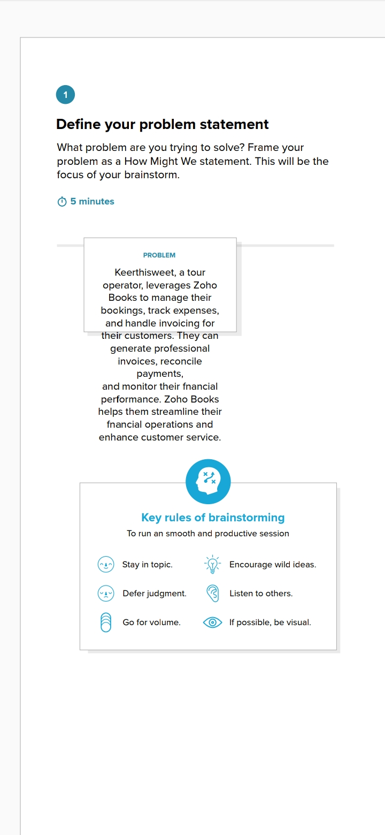
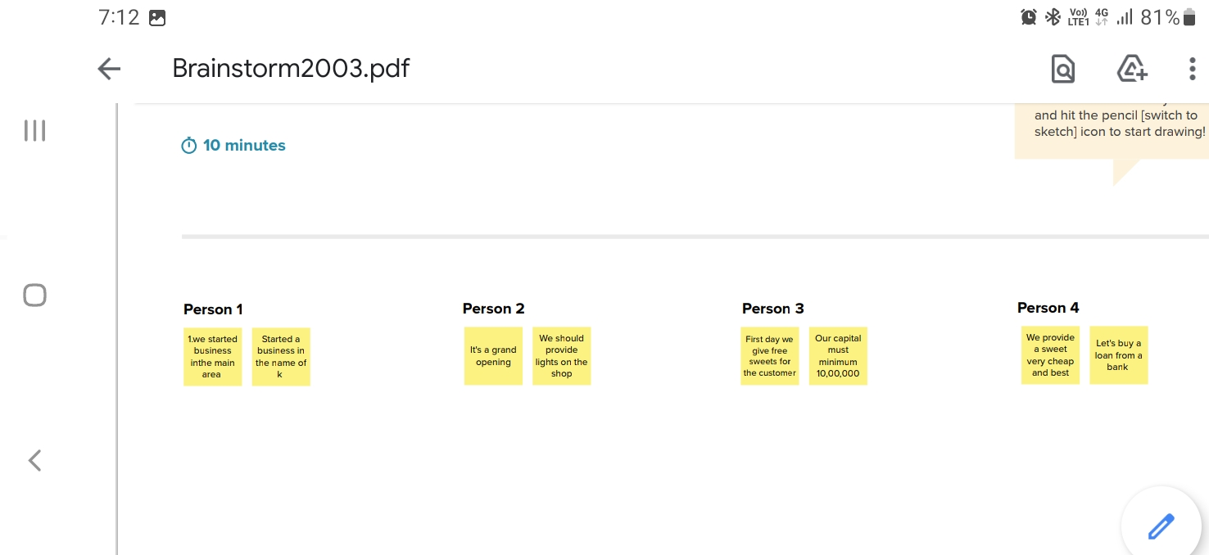
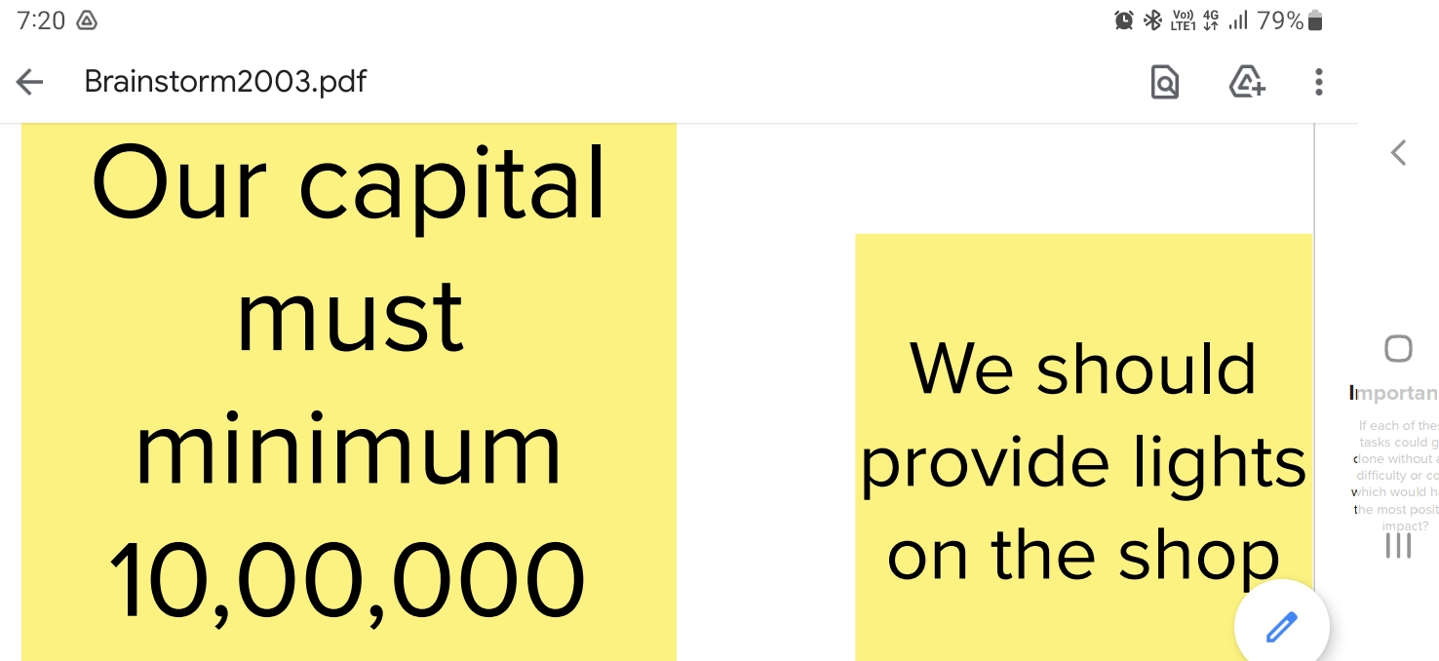

3,RESULT:
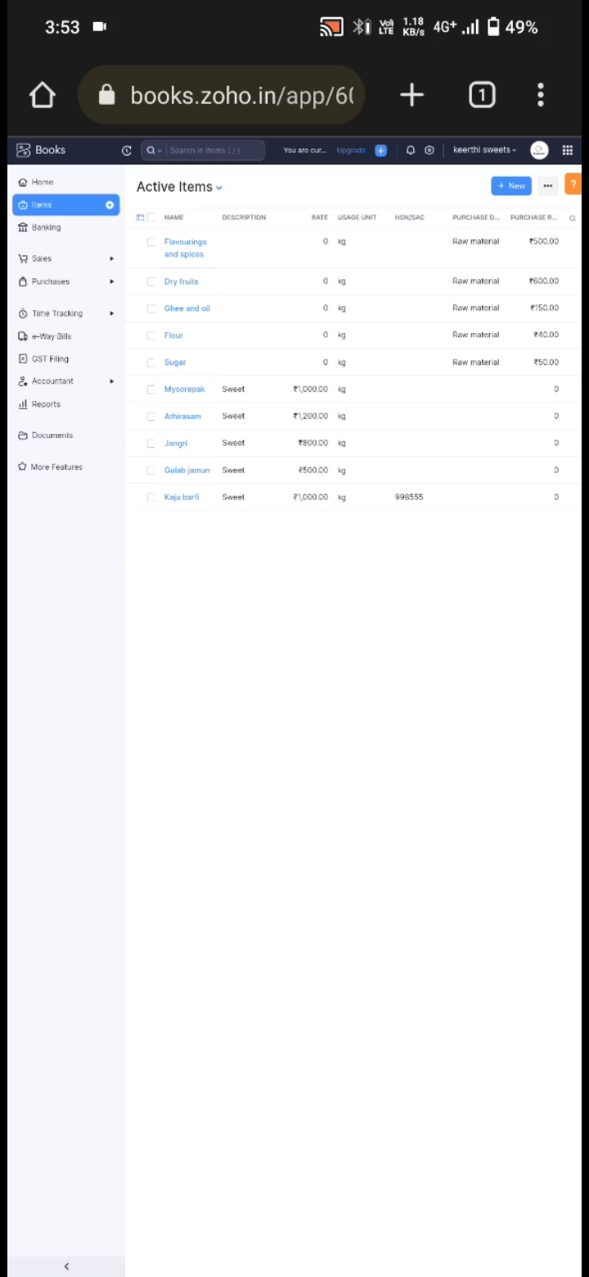
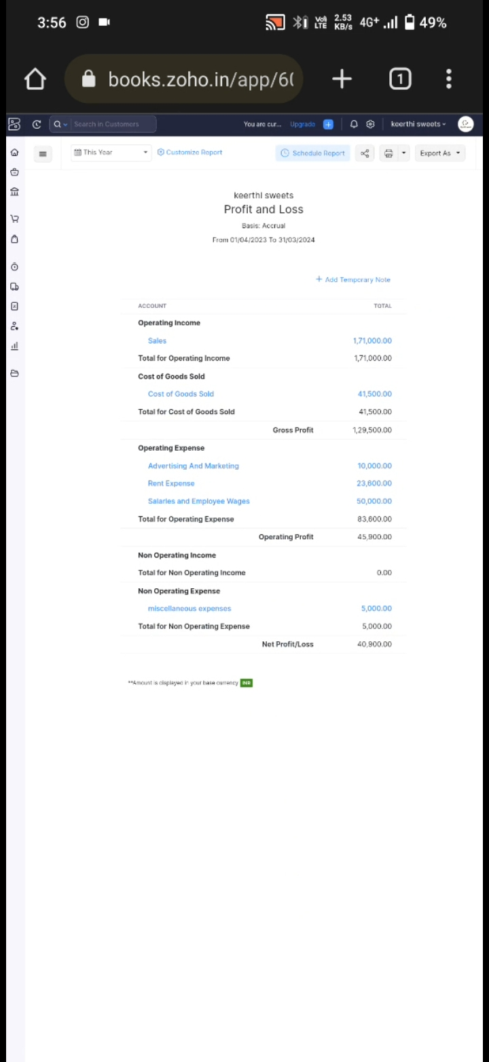
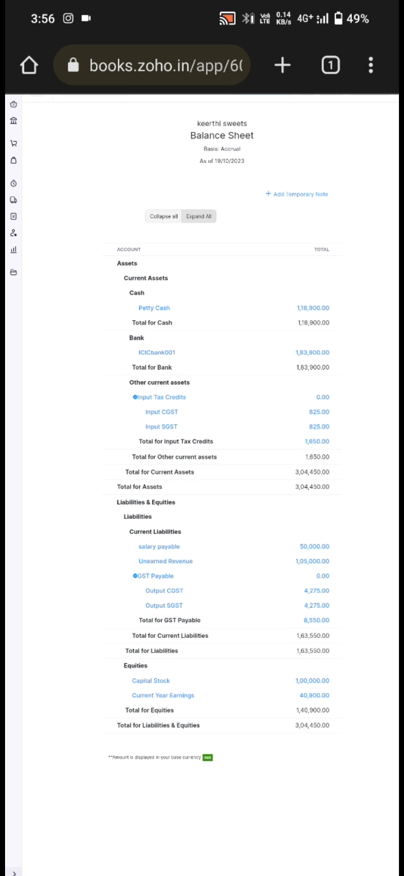
Information or specific data about individual businesses or their financial results, including Keerthi Sweets in Zoho Books. To get the financial results of Keerthi Sweets or any specific business using Zoho Books, you would need to contact the company directly or check any publicly available financial reports they may company directly or check any publicly available financial reports they may have published. If you have specific questions about using Zoho Books for accounting or need help with a related topic, feel free to ask, and I'll do my best to provide information and assistance based on my knowledge up to September 2021.
4: ADVANTAGES:
☆ Keerthi Sweet: Keerthi Sweet could refer to a particular type of Indian sweet or dessert.
☆ Laddu is a popular sweet in India made from ingredients like flour, sugar, and ghee.
☆ Keerthi Sweet might be a brand or a local sweet shop known for its laddus or other Indian sweets.
☆ Zoho Books: Zoho Books is an online accounting software designed for small and medium-sized businesses.
☆ It offers various features for managing financial transactions, invoicing, expense tracking, and more.
☆ It's a user- friendly solution that can help businesses streamline their accounting processes.

DISADVANTAGES:
☆ High in Sugar: Laddu is typically made with a significant amount of sugar, which can lead to a sudden spike in blood sugar levels when consumed. Overconsumption of sugar is associated with various health issues, diabetes and obesity.
☆Calorie Dense: Laddu is calorie-dense due to its ingredients, such as ghee and sugar. Excessive calorie intake can contribute to weight gain and obesity, which can lead to various health problems.
☆It's important to enjoy laddu and similar sweets in moderation. Incorporating them as an occasional treat in a balanced diet is a better approach to avoid the potential disadvantages associated with excessive consumption. If you have specific dietary concerns or health-related questions, it's advisable to consult with healthcare professional or a registered dietitian for personalized guidance.

5:APPLICATION:
Zoho Books is your one-stop platform for managing your
accounting tasks and organizing your transactions. It's a single
secure location to keep up with your company's bills and
invoices, reconcile your bank statements, control your
spending, oversee projects, and eliminate GST compliance
worries.
✓ Contact Management. Online Payments. Inventory
Management. Expenses. Mobile Apps.
✓ Collaborative Customer Portal. GST compliant accounting.
Project Time Tracking.
✓ Invoice Templates. Automatic Bank Feeds. Exhaustive
Reports.
ting
To sign up for Zoho Books:
• Click on the zoho link, it will navigate to Zoho books portal as
shown in the above picture.
• Enter your organisation details.
• Click Create Account.
• After signing up for Zoho Books, you’ll receive an email
through which you can verify your account
Enter your organisation details in the page you are redirected and click Get Started.

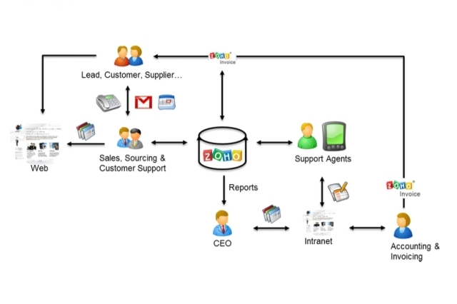
:

DASHBOARD:
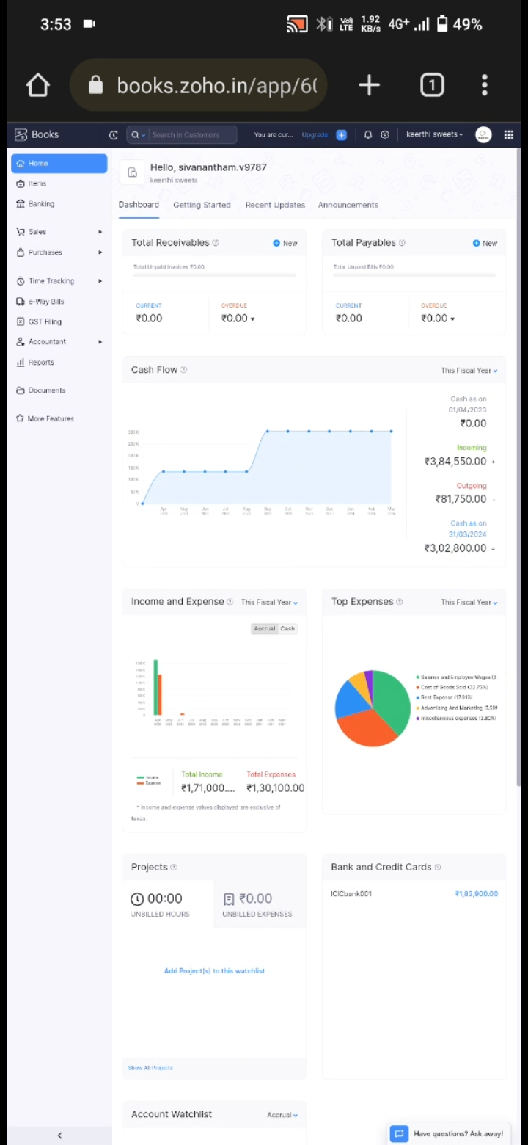
6,CONCLUSION:
Overall, the experience with Zoho Books is generally positive.
The software is well-designed, user-friendly, and provides a
range of features to support accounting and financial
management. The integrations with other Zoho apps and tools
are a big plus for businesses that already use Zoho products.
By now, you must have understood how Zoho Books is a
powerful and versatile online accounting software that can help businesses of all sizes manage their finances and streamline
their accounting processes.
The Zoho CRM can help in reducing the cost by centralized data
and free migration integration with a third-party application. It
will also increase sales by enabling sales automation. It provides
better customer segmentation and automates the sales report.
In the zoho books accounting software we can find the proper
analysis report.

7.FUTURE SCOPE:

As of my last knowledge update in September 2021, Zoho Books was a popular accounting and financial management software for small and medium-sized businesses. The software had various features for bookkeeping, invoicing, expense tracking, and financial reporting.

However, the future scope and developments of Zoho Books may have evolved since then. Here are some general areas where Zoho Books might have continued to improve and expand its offerings.

